**Task: Implement symmetric and asymmetric encryption using OpenSSL.**

**Symmetric Encryption:**

**Step 1:** Create the file to encrypt

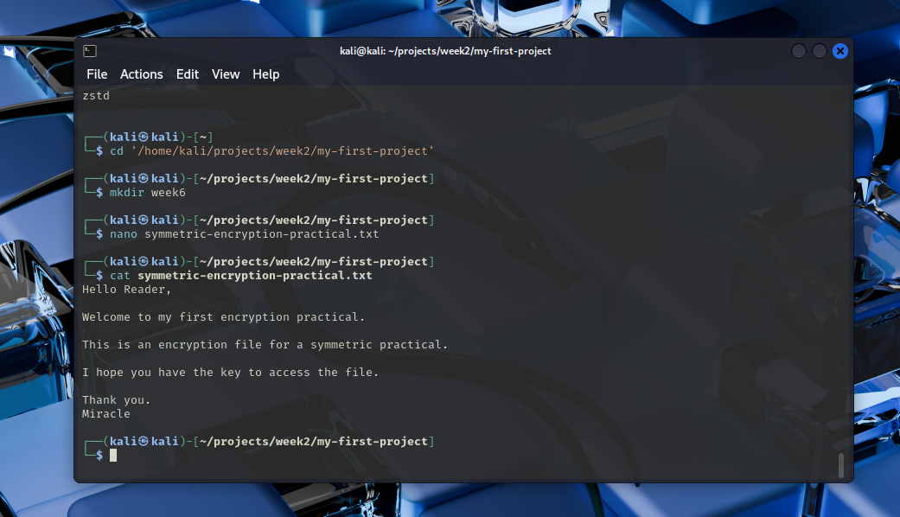

2. Create the Symmetric encryption using the command

‘

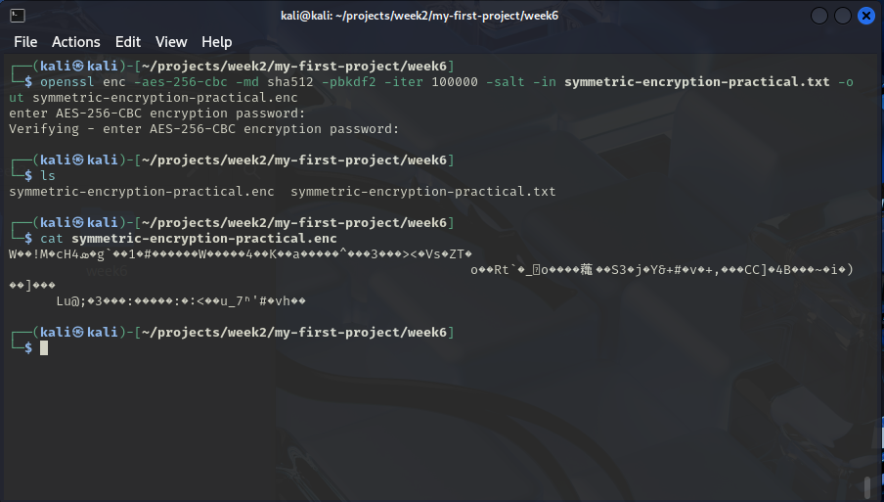

Step 3: Decode the file:

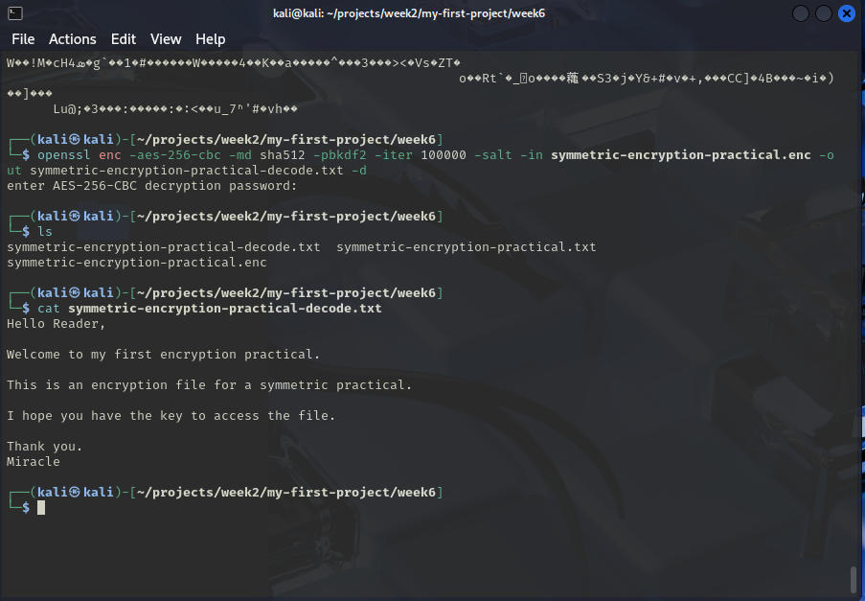

**Asymmetric Encryption**

Step 1: Create a private key

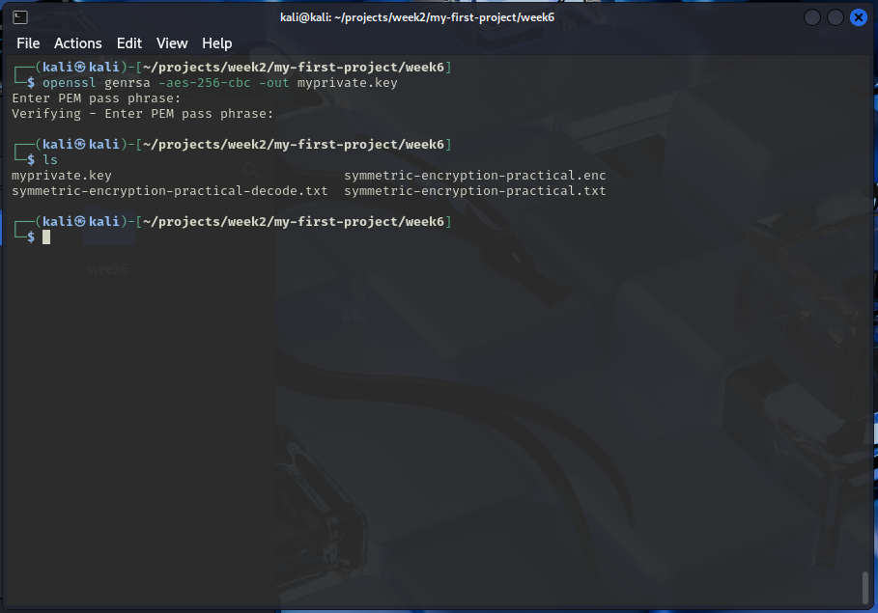

Step 2:  
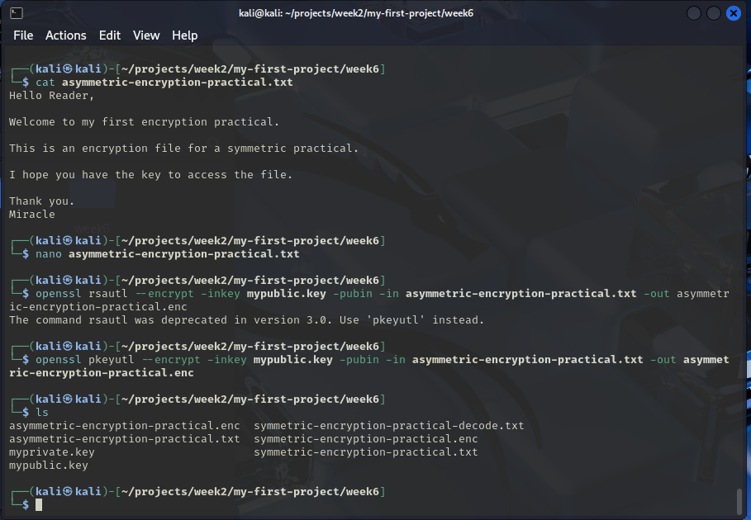

Step 3:

